SECURE FILE MANAGEMENT SYSTEM

Submitted in partial fulfilment of
The requirements for the degree of
Bachelor of Technology in Computer Science and Engineering with specialization Aritificial Intelligence and Machine Learning
at
Lovely professional University Phagwara, punjab
Submitted By
Kanuri Sampath kumar(12500337)
Tanisha Priya (12523177)
Harnoor singh thiara(12522790)
To
Manpreet Singh
Department
Of
Computer Science and Engineering

LOVELY PROFESSIONAL UNIVERSITY PHAGWARA, PUNJAB - 2025

Abstract
The Secure File Management System is a web-based application developed using React.js, designed to provide protected file storage and safe user authentication within a modern dashboard interface. The system integrates multi-layer security features including password-based login and email-based Two-Factor Authentication (2FA), ensuring that only verified users gain access to the stored files. It offers secure file handling capabilities such as encrypted storage, real-time file preview, controlled file renaming, deletion, and threat detection for malicious file types. A built-in security audit log records all system actions, including login attempts, file uploads, encryption events, and blocked operations, providing transparency and traceability. The application demonstrates essential concepts of cybersecurity, frontend engineering, and user-centered design, making it a practical prototype for secure digital file management. Future enhancements can extend the system with cloud storage, real encryption algorithms, role-based access control, and integrated database support.

Table of Contents

- Abstract
- Introduction
- Objectives of the Project
- Technologies Used
4.1 Programming Languages
4.2 Libraries and Tools
- System Architecture Overview
5.1 Authentication Module
5.2 Signup Module
5.3 User Roles
- File Management Features
6.1 Secure File Upload
6.2 Malicious File Detection
6.3 File Encryption and Decryption
6.4 File Deletion
6.5 File Renaming & Overflow Protection
- Dashboard User Interface
7.1 Navbar Section
7.2 Sidebar Navigation
7.3 My Files Section
7.4 File Viewer Module
- Security Audit Logs
- Threat Detection & Mitigation
- Conclusion
- References
- Appendix
13.1 Appendix A – Screenshots (Optional)
13.2 Appendix B – Code Snippets / Full Source Code
13.3 Appendix C – Project Flow Diagram

1. Introduction
The Secure File Management System is a web-based application developed using React.js, designed to provide a protected environment for storing, uploading, encrypting, decrypting, and managing digital files. The system emphasizes security, usability, and efficient file handling, making it suitable for educational, organizational, and enterprise-level scenarios.
To ensure secure user access, the system implements multi-layer authentication, which includes a standard password-based login combined with Email OTP–based Two-Factor Authentication (2FA). This additional layer of verification strengthens user identity validation and reduces the risk of unauthorized access.
Beyond authentication, the application demonstrates how modern secure dashboards—similar to platforms like Google Drive or OneDrive with enhanced security features—manage sensitive files. It includes simulated modules for malware detection, file encryption, file integrity checks, and audit logging, allowing users to understand real-world cybersecurity workflows within a user-friendly interface.
Overall, this project showcases the integration of front-end technologies with core security principles, delivering a conceptual yet practical demonstration of how secure file management systems operate in real-world environments.

2. Objectives of the Project
The primary objectives of the Secure File Management System are centered around delivering a robust, safe, and user-friendly platform for handling sensitive digital files. The major goals of this project include:
1. Provide a Secure File Storage Environment
Enable users to store and manage their files within a protected system that prioritizes confidentiality and integrity.
2. Ensure Safe User Authentication
Allow users to sign up and log in securely using multi-layer authentication, including password-based login and Email OTP–based Two-Factor Authentication (2FA).
3. Implement AES-256–Style Encryption Toggling
Offer users the ability to encrypt or decrypt files using a simulated AES-256 encryption mechanism for enhanced data protection.
4. Detect Malicious Files
Prevent harmful files from being uploaded by integrating a simulated malware detection module.
5. Maintain System Audit Logs
Track every user activity such as login attempts, file uploads, encryption actions, and deletions to improve transparency and accountability.
6. Deliver a Clean and Modern User Interface Ensure a smooth user experience with a modern UI, real-time feedback, and responsive design for all system interactions.

3. Technologies Used
The Secure File Management System is built using modern web development technologies that ensure efficiency, responsiveness, and ease of use. The following technologies form the core of the application:
🔹 React.js
A component-based JavaScript framework used to build the dynamic and interactive user interface.
🔹 Tailwind CSS
A utility-first CSS framework used for rapid UI design, providing a clean, responsive, and modern layout.
🔹 Lucide-React
An icon library used to render lightweight and customizable icons throughout the application.
🔹 JavaScript (ES6+)
Used for application logic, state management, authentication handling, and interaction between different modules.
🔹 HTML5 FileReader API
Enables reading and processing content of uploaded files directly on the client side.
🔹 Local Simulated Database (Arrays)
Temporary in-memory arrays are used to simulate users, files, and audit logs in place of a real backend.

4. System Architecture Overview with subsections
4.1 Authentication Module and 4.2 User Roles:

4. System Architecture Overview
The Secure File Management System follows a modular and layered architecture, ensuring separation of concerns and smooth interaction between the authentication system, dashboard, file management unit, and audit logging components. The architecture ensures security, reliability, and controlled access at every stage.

4.1 Authentication Module
The Authentication Module is one of the most important parts of the system. It ensures that only authorized users can access the dashboard. It includes three major components:

a) Login System
- Users enter their username and password.
- The system verifies credentials using a simulated database named registeredUsers.
- If the username or password is incorrect, login is denied and an error is shown.
- Only validated users can proceed to the next security step (2FA).

b) Two-Factor Authentication (2FA)
After successful password verification:
- The system generates and displays a simulated OTP (123456).
- The interface switches to OTP input mode.
- The user enters the OTP and submits it.
- Only correct OTP authentication grants access to the Secure Dashboard.
- If incorrect, access is denied and user stays on OTP screen.

c) Signup System
New users can create an account by entering:
- Username
- Email
- Password
- Confirm Password
Additional security:
- Email verification is simulated before the account gets added to registeredUsers.
- The system ensures:
  - Passwords match
  - Username is unique
  - Email is valid in structure

4.2 User Roles
The system currently supports two user roles:
🔹 Admin
- Has elevated permissions.
- Can view all files.
- Can manage system-level tasks.
- Has visibility over audit logs.
🔹 User
- Has regular access.
- Can upload, view, encrypt/decrypt their own files.
- Limited system-level control.

5. File Management Features
The Secure File Management System provides a robust set of functionalities to ensure safe, controlled, and secure handling of files. These features simulate how enterprise systems perform secure file operations with built-in threat detection and audit logging.

5.1 File Upload
Users can upload files directly through the dashboard interface. When a file is selected:
- The system reads its metadata and content using the HTML5 FileReader API.
- File type and extension are evaluated to determine whether it is safe for upload.
Malicious File Blocking
To protect the environment, the system automatically checks for high-risk file types such as:
.exe, .bat, .sh, .cmd, .vbs
If a dangerous file is detected:
- The file upload is blocked immediately.
- The user receives an alert message.
- A Critical Security Log Entry is created in the Audit Logs module.
This mechanism simulates anti-malware and threat-prevention checks used in modern secure storage systems.

5.2 File Encryption and Decryption
Each uploaded file can be toggled between Encrypted and Decrypted states.
- The system uses a simulated AES-256 encryption algorithm.
- Each file has an encrypted boolean flag.
- Encryption is reversible through a controlled decryption process.
Whenever a file is encrypted or decrypted:
- A corresponding Audit Log entry is generated.
- The UI updates the file status in real time.
This feature represents modern cloud systems where sensitive files remain encrypted at rest.

5.3 File Deletion
Users may delete any of their stored files.
Upon deletion:
- The file is permanently removed from the simulated database.
- The system logs the event as:
File ‘filename’ deleted.
This ensures proper traceability and accountability for all destructive actions.

5.4 File Renaming with Buffer Overflow Protection
Renaming a file is supported with integrated security validation.
Security Check: Buffer Overflow Protection
- Maximum allowed filename length: 30 characters
- If the new name exceeds the limit:
  - The rename operation is blocked
  - A “Buffer Overflow Blocked” log entry is created
  - User receives a security alert
This models real-world defensive programming techniques that prevent memory corruption vulnerabilities.

6. Dashboard UI Sections
The Secure File Management System features a clean, modern, and responsive dashboard built using React.js and Tailwind CSS. The structure ensures that users can navigate easily while maintaining high security and usability standards.

6.1 Navbar
The top navigation bar remains visible across all pages. It displays essential system information and quick controls:
- Application Logo – Represents the secure system identity
- System Security Status Indicator – Shows whether the system is in a safe or warning state
- Logged-in Username – Helps users confirm their active session
- Logout Button – Allows secure sign-out at any time
The Navbar ensures continuous visibility of the user’s authentication state.

6.2 Sidebar
The left-side vertical menu provides all major navigation options. It contains:
- Secure Upload Button – Opens the file upload modal
- Navigation Links
  - My Drive – Displays user files
  - Security Audit Logs – Shows all system activity with timestamps
- Storage & Gateway Status
  - Displays total storage used
  - Shows simulated network or gateway health
This section makes all core operations easily accessible.

6.3 My Files Section
This is the main working area where all user files are displayed in a structured list. Each file entry includes:
- File Name
- File Type & Size
- Owner (User)
- Encryption Status (Encrypted / Decrypted)
- Action Buttons
  - View
  - Rename
  - Encrypt/Decrypt
  - Delete
This interface allows smooth file handling similar to systems like Google Drive or OneDrive.

6.4 File Viewer Modal
Upon clicking View, a file preview modal appears. The viewer adapts based on file type:
- Text Files (.txt) → Displayed as plain text
- JSON Files → Shown in a formatted structure for readability
- Image Files (png, jpg, jpeg) → Previewed through Base64-rendered images
- PDF Files → Loaded using a Data URL and displayed inside an iframe
A zoom feature is also provided to make reading or inspecting files easier.
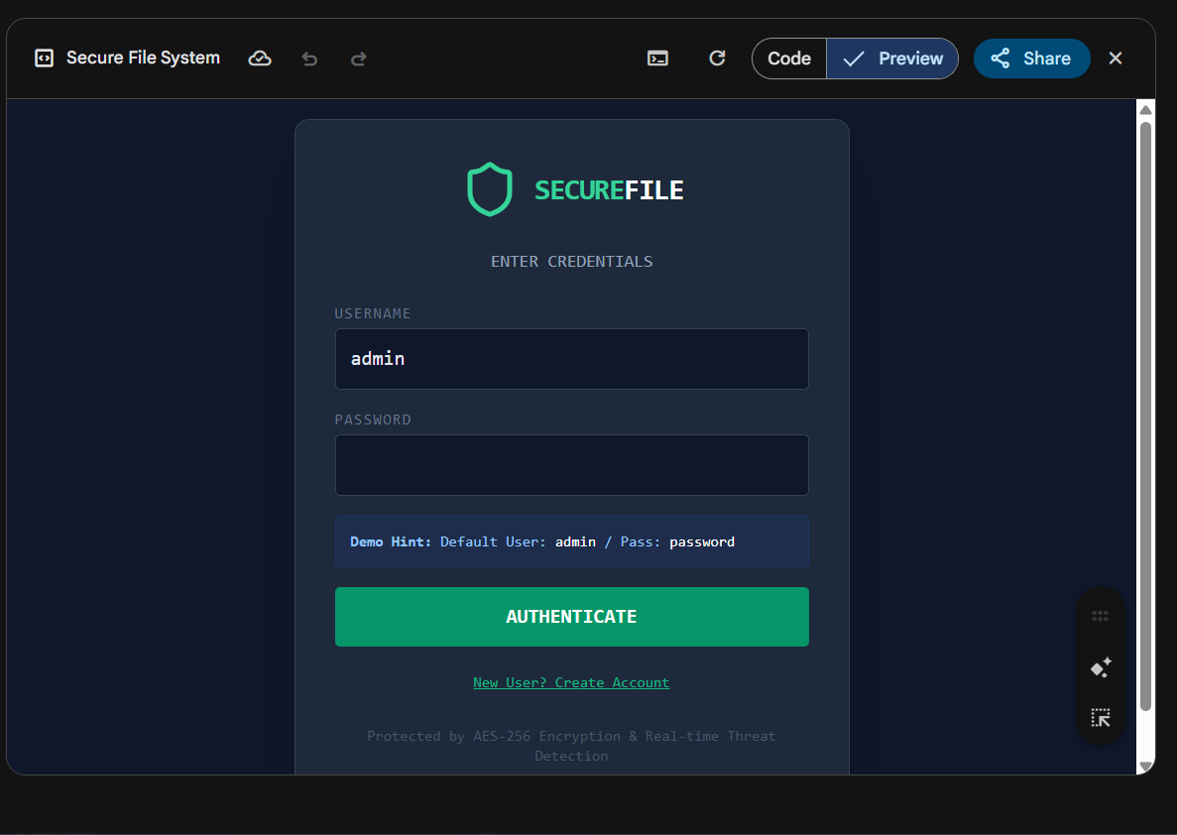
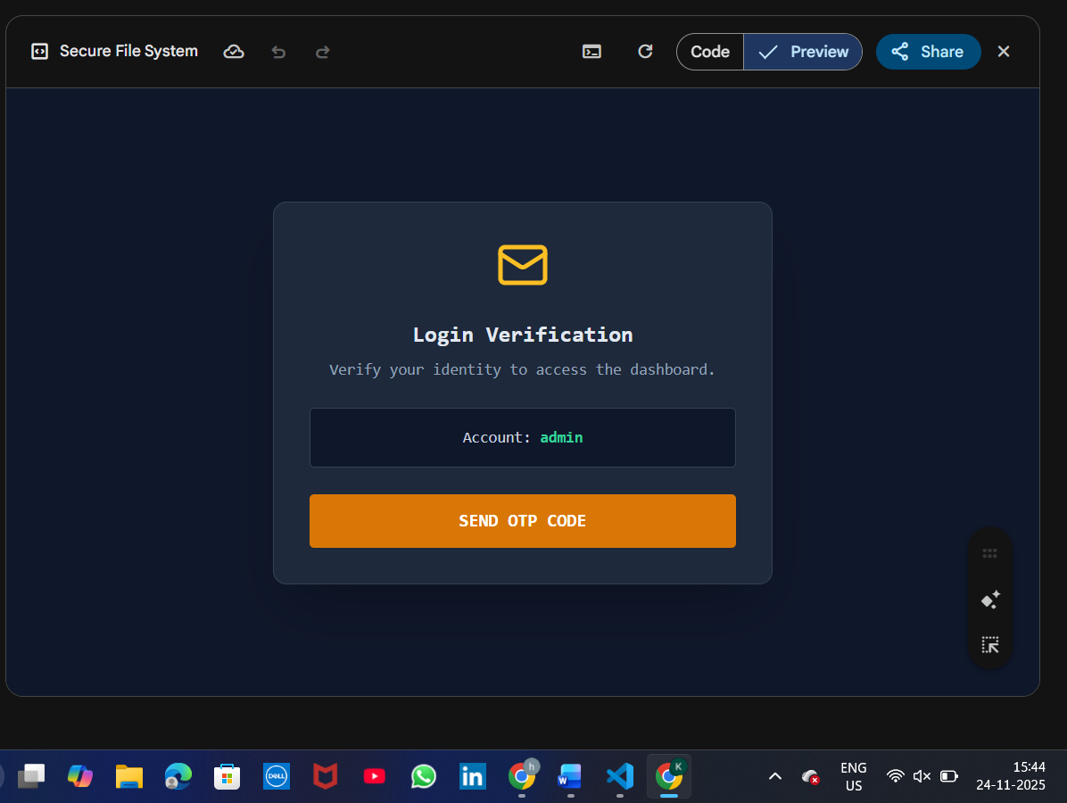

7. Security Audit Logs
The Security Audit Log module is one of the most critical components of the Secure File Management System. It ensures complete traceability of user activity and system behavior, which is essential for maintaining high-level security and accountability.
Audit logging is commonly used in SOC (Security Operations Center) environments, and this project simulates that functionality effectively.

7.1 Purpose of Audit Logs
The audit log system helps in:
- Tracking user actions
- Detecting suspicious or malicious events
- Providing accountability
- Supporting debugging and incident investigation
- Ensuring transparency in system operations

7.2 Events Logged in the System
Every critical event is recorded with full details. Logged actions include:
- Login Attempts (success or failure)
- Incorrect Password Attempts
- OTP Verification (correct/incorrect OTP submission)
- File Upload (valid or blocked file)
- File Encryption / Decryption Actions
- File Deletion
- File Rename
- Rename Blocked due to Buffer Overflow (Filename > 30 characters)
These logs help detect patterns of misuse or potential security threats.

7.3 Log Details Captured
Each log entry contains the following metadata:
- Timestamp – Exact time of the event
- Log Type – Categorized as:
  - Info
  - Warning
  - Success
  - Error
  - Critical
- Description / Message – Meaningful human-readable explanation of the event
Example:
“[CRITICAL] Attempt to upload blocked executable file: virus.exe”

7.4 Importance in Cyber Security
By maintaining detailed audit logs, the system mimics real-world security workflows used in:
- SOC Centers
- Enterprise File Management Systems
- Secure Cloud Storage Services
This makes the project realistic and aligns with industry standards.
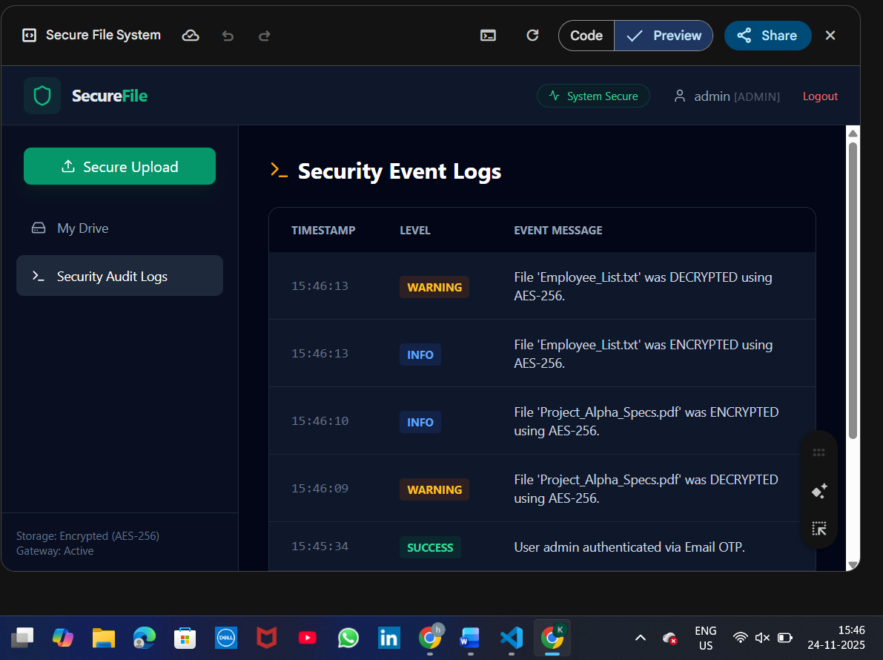

8. Threat Detection & Mitigation
The Secure File Management System incorporates multiple layers of defense to protect user data and prevent unauthorized activities. These mechanisms simulate real-world security practices used in enterprise and cloud environments.

8.1 Key Security Measures Implemented
Malicious File Detection
The system scans file extensions during upload.
Files with dangerous extensions such as .exe, .bat, .sh, .cmd, and .vbs are automatically blocked.
A critical audit log is generated for every blocked attempt.

Buffer Overflow Prevention
When renaming a file, the system enforces a strict 30-character limit.
If exceeded, the rename request is denied and a “Buffer Overflow Blocked” audit log is added.
This simulates memory corruption and input-validation safeguards found in secure systems.

Two-Factor Authentication (2FA)
User login requires:
- Correct password, and
- Correct OTP (123456) for second-level verification.
This prevents access even if the password is compromised.

Unauthorized Access Prevention
Only verified and logged-in users can access the dashboard.
Incorrect password or OTP immediately stops further access and adds security logs.

Encrypted Storage Simulation
Files can be toggled between:
- Encrypted (AES-256 simulated)
- Decrypted (Readable)
This feature demonstrates secure data-at-rest practices.

Audit Monitoring
Every action—valid or malicious—is recorded with:
- Time
- Event type
- Message
Continuous logging assists in tracking suspicious behavior, similar to SOC monitoring systems.
9. Flow Diagram
Below is the full flow of the Secure File Management System, from authentication to file operations and logging.

🔹 Flow Diagram (Block Representation)
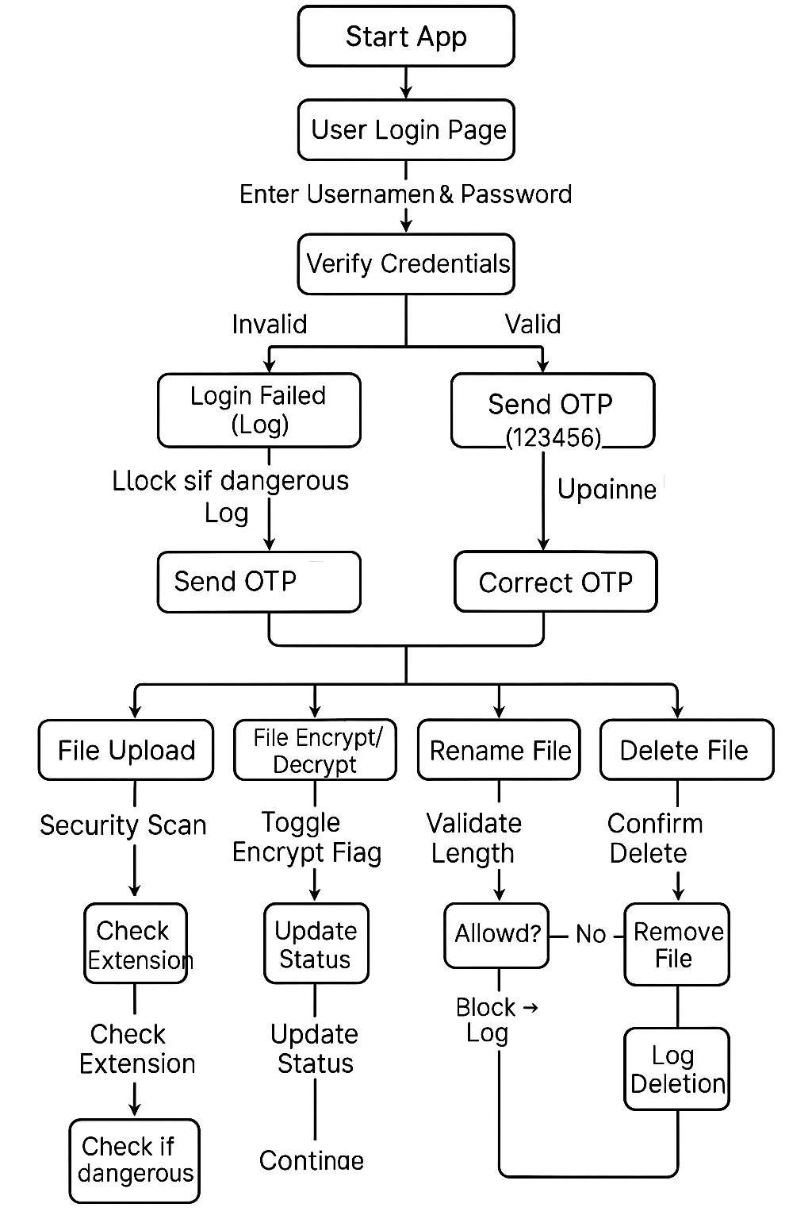
🔹 Explanation of Flow
1. Authentication Flow
- User logs in → credentials verified
- If correct → OTP generated
- OTP verified → access granted
- All steps are logged
2. File Management Flow
- Upload → Malicious file detection → allowed/blocked
- Encrypt/Decrypt → toggle status → log entry
- Rename → length validation → success/block
- Delete → remove file → add log
3. Audit Logging Flow
Every action generates logs with:
- Timestamp
- Type (info, success, warning, error, critical)
- Description

10 Revision Tracking on GitHub
- Repository Name:
Secure-File-Management-System
OS-project
- GitHub Link:
https://github.com/SampathKumar-4036077/Secure-File-Management-System
https://github.com/Hrex2/OS-project

11. Conclusion and Future Scope
Conclusion
The Secure File Management System successfully demonstrates the essential components of modern, security-focused web applications. By utilizing React.js, Tailwind CSS, and simulated encryption, the project replicates how real-world platforms handle secure file storage and user authentication.
Key achievements of this project include:
- Implementation of multi-layer authentication (password + OTP)
- Safe and controlled file upload system
- Malware detection using harmful extension blocking
- AES-256–style encryption simulation for protecting files
- Real-time Audit Logging for transparency and incident tracking
- A clean and fully functional dashboard interface

Future Scope
Although the current implementation is fully functional as a demonstration, it can be expanded into a production-ready system with the following enhancements:
1. Real Backend Integration
- Replace simulated arrays with Node.js + Express or Django REST API
- Use a real database such as MongoDB, MySQL, or PostgreSQL
2. Real Encryption
- Implement actual AES-256 encryption using Crypto libraries
- Store encrypted files on the server or cloud (AWS S3, Firebase Storage)
3. Enhanced Malware Detection
- Integrate lightweight antivirus APIs (e.g., VirusTotal API)
- Perform signature-based or heuristic scanning
4. Role-Based Access Control (RBAC)
- More granular permissions such as:
  - Admin
  - User
  - Audit Manager
  - Security Analyst
5. Multi-User Collaboration
- File sharing
- Permissions (Read-only, Edit, Download)
- Shared drives
6. Cloud Deployment
- Host the application using:
  - Vercel
  - Netlify
  - AWS
  - GitHub Pages
7. Advanced Logging & Monitoring
- Integration with:
  - Elastic Stack (ELK)
  - Grafana
  - Prometheus
- Real-time security dashboards
8. Improved UI/UX
- Dark mode
- Drag-and-drop upload
- Notification panel
- Improved animations

12. References
The following resources were used to support development, validation, and understanding of concepts used in the Secure File Management System:
- React.js Documentation
https://react.dev
- Tailwind CSS Documentation
https://tailwindcss.com
- Lucide React Icons
https://lucide.dev
- JavaScript ES6 Documentation – MDN Web Docs
https://developer.mozilla.org
- FileReader API – MDN
https://developer.mozilla.org/en-US/docs/Web/API/FileReader
- OWASP Security Guidelines (for understanding threats & mitigation)
https://owasp.org
- AES Encryption Concepts – NIST
https://csrc.nist.gov
- Academic and online articles related to secure file storage and file-type vulnerability research.

13. Appendix
This section contains supporting materials including AI-generated explanation, problem statement, and final project code.

A. AI-Generated Project Elaboration / Breakdown Report
The Secure File Management System is a security-focused web application designed to protect sensitive files through controlled access and encrypted storage. It integrates user authentication, OTP verification, and role-based permissions to ensure only authorized users can upload, download, or delete files. The system maintains detailed activity logs, applies strict validation during file operations, and uses a professional, user-friendly interface for smooth interaction. By combining authentication, encryption, and monitoring, the project demonstrates a practical and reliable approach to secure digital file handling.

B. Problem Statement
Organizations and academic institutions frequently manage sensitive digital files that require strict access control and protection. Traditional file storage methods often lack security layers such as authentication, encryption, and activity monitoring. As a result, files become vulnerable to unauthorized access, accidental deletion, data leaks, and manipulation.
There is a need for a secure, web-based system that ensures only verified users can upload, download, and delete files. The system must incorporate strong authentication, OTP verification, encrypted file storage, role-based permissions, and action logging to maintain confidentiality, integrity, and accountability.
The Secure File Management System aims to solve these issues by providing a protected environment where users can safely interact with files while ensuring full security, controlled access, and complete traceability.

C. Solution / Code
import React, { useState, useEffect, useRef } from 'react';
import {
Shield,
Lock,
Unlock,
FileText,
Upload,
AlertTriangle,
User,
Key,
Share2,
Trash2,
Eye,
Activity,
CheckCircle,
XCircle,
Menu,
Terminal,
Search,
HardDrive,
Mail,
Plus,
Minus,
Maximize
} from 'lucide-react';

// --- Mock Data & Utilities ---

const INITIAL_FILES = [
{ id: 1, name: 'Project_Alpha_Specs.pdf', size: '2.4 MB', type: 'pdf', owner: 'admin', encrypted: true, content: 'Confidential specifications for Project Alpha...' },
{ id: 2, name: 'Q3_Financials.xlsx', size: '1.1 MB', type: 'xlsx', owner: 'finance', encrypted: true, content: 'Revenue stream data...' },
{ id: 3, name: 'Employee_List.txt', size: '14 KB', type: 'txt', owner: 'hr', encrypted: false, content: 'John Doe, Jane Smith...' },
{ id: 4, name: 'System_Config.json', size: '4 KB', type: 'json', owner: 'admin', encrypted: false, content: '{ "version": "1.0.4" }' },
];

const generateId = () => Math.floor(Math.random() * 100000);

const getCurrentTime = () => new Date().toLocaleTimeString([], { hour: '2-digit', minute: '2-digit', second: '2-digit' });

// --- Main Component ---

export default function SecureFileSystem() {
// User Database (Simulated Backend)
const [registeredUsers, setRegisteredUsers] = useState([
{ username: 'admin', password: 'password', email: 'admin@securefile.io' }
]);

// Auth State
const [authStep, setAuthStep] = useState('login'); // login, 2fa, signup, dashboard
const [currentUser, setCurrentUser] = useState(null);

// Inputs
const [usernameInput, setUsernameInput] = useState('admin');
const [passwordInput, setPasswordInput] = useState('');
const [emailInput, setEmailInput] = useState('');
const [confirmPasswordInput, setConfirmPasswordInput] = useState('');
const [otpInput, setOtpInput] = useState('');

// Process State
const [authError, setAuthError] = useState('');
const [signupStep, setSignupStep] = useState('details'); // 'details' | 'otp'
const [isSimulatingEmail, setIsSimulatingEmail] = useState(false);
const [otpSent, setOtpSent] = useState(false); // Used for Login 2FA
const [zoomLevel, setZoomLevel] = useState(100); // New state for Zoom

// App State
const [files, setFiles] = useState(INITIAL_FILES);
const [logs, setLogs] = useState([{ time: getCurrentTime(), type: 'info', message: 'System initialized. WAF Active.' }]);
const [activeTab, setActiveTab] = useState('files');
const [modal, setModal] = useState(null);

// --- Security Logic & Helpers ---

const addLog = (type, message) => {
setLogs(prev => [{ time: getCurrentTime(), type, message }, ...prev]);
};

const resetInputs = () => {
setPasswordInput('');
setConfirmPasswordInput('');
setOtpInput('');
setAuthError('');
setEmailInput('');
};

// --- Login Logic ---

const handleLogin = (e) => {
e.preventDefault();

// 1. Validate Credentials against "Database"
const foundUser = registeredUsers.find(u => u.username === usernameInput);

if (!foundUser) {
setAuthError('User not registered.');
addLog('error', `Login failed: Unknown user '${usernameInput}'`);
return;
}

if (foundUser.password !== passwordInput) {
setAuthError('Invalid credentials.');
addLog('warning', `Failed login attempt for user: ${usernameInput}`);
return;
}

// 2. Proceed to 2FA
setAuthStep('2fa');
setAuthError('');
setOtpSent(false);
addLog('info', `Credentials verified for ${usernameInput}. Requesting 2FA.`);
};

const handleSendLoginOTP = () => {
setIsSimulatingEmail(true);
setAuthError('');

const userEmail = registeredUsers.find(u => u.username === usernameInput)?.email || 'user@email.com';

setTimeout(() => {
setIsSimulatingEmail(false);
setOtpSent(true);
addLog('info', `2FA OTP Code sent to ${userEmail}`);
}, 1500);
};

const handleVerifyLogin2FA = (e) => {
e.preventDefault();
if (otpInput === '123456') {
setCurrentUser({ name: usernameInput, role: usernameInput === 'admin' ? 'admin' : 'user' });
setAuthStep('dashboard');
addLog('success', `User ${usernameInput} authenticated via Email OTP.`);
} else {
setAuthError('Invalid OTP Code');
addLog('error', `Failed OTP attempt for ${usernameInput}`);
}
};

// --- Signup Logic ---

const handleInitiateSignup = (e) => {
e.preventDefault();
setAuthError('');

if (passwordInput.length < 4) {
setAuthError('Password too short (Min 4 chars)');
return;
}
if (passwordInput !== confirmPasswordInput) {
setAuthError('Passwords do not match');
return;
}
if (!emailInput.includes('@')) {
setAuthError('Invalid email address');
return;
}
if (registeredUsers.find(u => u.username === usernameInput)) {
setAuthError('Username already taken');
return;
}

setIsSimulatingEmail(true);

// Simulate sending Verification Email
setTimeout(() => {
setIsSimulatingEmail(false);
setSignupStep('otp');
addLog('info', `Verification code sent to ${emailInput} for new account registration.`);
}, 1500);
};

const handleVerifySignupOTP = (e) => {
e.preventDefault();
if (otpInput === '123456') {
// Create User
const newUser = {
username: usernameInput,
password: passwordInput,
email: emailInput
};
setRegisteredUsers([...registeredUsers, newUser]);

addLog('success', `New account registered: ${usernameInput}`);
alert("Account verified and created successfully! Please log in.");

// Reset to Login
setAuthStep('login');
setSignupStep('details');
resetInputs();
} else {
setAuthError('Invalid OTP Code');
}
};

// --- File Operations ---

const toggleEncryption = (fileId) => {
setFiles(files.map(f => {
if (f.id === fileId) {
const newState = !f.encrypted;
addLog(newState ? 'info' : 'warning', `File '${f.name}' was ${newState ? 'ENCRYPTED' : 'DECRYPTED'} using AES-256.`);
return { ...f, encrypted: newState };
}
return f;
}));
};

const deleteFile = (id) => {
const file = files.find(f => f.id === id);
setFiles(files.filter(f => f.id !== id));
addLog('warning', `File '${file.name}' deleted.`);
};

const handleFileUpload = (e) => {
const file = e.target.files[0];
if (!file) return;

const name = file.name;
const extension = name.split('.').pop().toLowerCase();
const maliciousExtensions = ['exe', 'bat', 'sh', 'cmd', 'vbs'];

if (maliciousExtensions.includes(extension)) {
addLog('critical', `MALWARE BLOCKED: '${name}' contains executable payload.`);
alert("SECURITY ALERT: Malicious file signature detected. Upload blocked.");
return;
}

// Use FileReader to read the actual file content
const reader = new FileReader();

reader.onload = (event) => {
const fileContent = event.target.result;

const newFile = {
id: generateId(),
name: name,
size: (file.size / 1024).toFixed(1) + ' KB',
type: extension,
owner: currentUser?.name || 'system',
encrypted: false,
content: fileContent // Stores actual text content or Base64 Data URL
};

setFiles([newFile, ...files]);
addLog('success', `File '${name}' uploaded successfully.`);
};

reader.onerror = () => {
addLog('error', `Error reading file: ${name}`);
alert("Failed to read file content.");
};

// Determine reading method based on file type
if (['png', 'jpg', 'jpeg', 'gif', 'pdf'].includes(extension)) {
// Read binary files (Images, PDFs) as Data URL for display
reader.readAsDataURL(file);
} else {
// Read others as text
reader.readAsText(file);
}
};

const handleRename = (fileId, newName) => {
if (newName.length > 30) {
addLog('critical', `BUFFER OVERFLOW BLOCKED: Rename input exceeded memory allocation (${newName.length} chars).`);
alert("SECURITY WARNING: Input length exceeds buffer limit. Operation blocked to prevent memory corruption.");
return;
}
setFiles(files.map(f => f.id === fileId ? { ...f, name: newName } : f));
setModal(null);
addLog('info', `File renamed to '${newName}'.`);
};

// Helper to open modal and reset zoom
const openModal = (type, file) => {
setModal({ type, file });
setZoomLevel(100);
}

// --- Render Views ---

// 1. SIGNUP VIEW
if (authStep === 'signup') {
return (
<div className="min-h-screen bg-slate-900 flex items-center justify-center p-4 font-mono text-slate-200">
<div className="bg-slate-800 border border-slate-700 p-8 rounded-xl shadow-2xl max-w-md w-full">
<div className="flex items-center justify-center mb-6 text-emerald-400">
<Shield className="w-10 h-10 mr-3" />
<h1 className="text-xl font-bold tracking-tighter">REGISTER<span className="text-white">USER</span></h1>
</div>

{signupStep === 'details' ? (
<form onSubmit={handleInitiateSignup} className="space-y-4 animate-in fade-in">
<h2 className="text-center text-slate-400 mb-4 text-sm">ACCOUNT DETAILS</h2>
<div>
<label className="block text-xs uppercase tracking-widest mb-1 text-slate-500">Username</label>
<input type="text" value={usernameInput} onChange={(e) => setUsernameInput(e.target.value)} className="w-full bg-slate-900 border border-slate-700 rounded p-2 focus:border-emerald-500 focus:outline-none" />
</div>
<div>
<label className="block text-xs uppercase tracking-widest mb-1 text-slate-500">Email Address</label>
<input type="email" value={emailInput} onChange={(e) => setEmailInput(e.target.value)} className="w-full bg-slate-900 border border-slate-700 rounded p-2 focus:border-emerald-500 focus:outline-none" />
</div>
<div className="grid grid-cols-2 gap-2">
<div>
<label className="block text-xs uppercase tracking-widest mb-1 text-slate-500">Password</label>
<input type="password" value={passwordInput} onChange={(e) => setPasswordInput(e.target.value)} className="w-full bg-slate-900 border border-slate-700 rounded p-2 focus:border-emerald-500 focus:outline-none" />
</div>
<div>
<label className="block text-xs uppercase tracking-widest mb-1 text-slate-500">Confirm</label>
<input type="password" value={confirmPasswordInput} onChange={(e) => setConfirmPasswordInput(e.target.value)} className="w-full bg-slate-900 border border-slate-700 rounded p-2 focus:border-emerald-500 focus:outline-none" />
</div>
</div>
{authError && <div className="text-red-500 text-xs flex items-center"><AlertTriangle className="w-3 h-3 mr-1" /> {authError}</div>}
<button disabled={isSimulatingEmail} className="w-full bg-emerald-600 hover:bg-emerald-500 text-white font-bold py-3 rounded transition-all disabled:opacity-50">
{isSimulatingEmail ? 'SENDING VERIFICATION...' : 'VERIFY EMAIL & REGISTER'}
</button>
</form>
) : (
<form onSubmit={handleVerifySignupOTP} className="space-y-6 animate-in slide-in-from-right-8">
<div className="text-center">
<Mail className="w-12 h-12 mx-auto text-emerald-400 mb-2" />
<h2 className="text-xl font-bold">Verify Email</h2>
<p className="text-xs text-slate-400 mt-2">Code sent to <span className="text-white">{emailInput}</span></p>
</div>

<input
type="text"
placeholder="000000"
maxLength="6"
value={otpInput}
onChange={(e) => setOtpInput(e.target.value)}
className="w-full bg-slate-900 border border-slate-700 rounded p-4 text-center text-2xl tracking-[1em] focus:border-emerald-500 focus:outline-none"
autoFocus
/>
<p className="text-xs text-center text-slate-500">(Use code: 123456)</p>
{authError && <div className="text-red-500 text-sm flex items-center justify-center"><XCircle className="w-4 h-4 mr-2" /> {authError}</div>}

<button className="w-full bg-emerald-600 hover:bg-emerald-500 text-white font-bold py-3 rounded transition-all">
CONFIRM ACCOUNT
</button>
</form>
)}

<div className="mt-4 text-center">
<button onClick={() => { setAuthStep('login'); resetInputs(); }} className="text-xs text-emerald-500 hover:text-emerald-400 underline">
Already have an account? Login
</button>
</div>
</div>
</div>
);
}

// 2. LOGIN VIEW
if (authStep === 'login') {
return (
<div className="min-h-screen bg-slate-900 flex items-center justify-center p-4 font-mono text-slate-200">
<div className="bg-slate-800 border border-slate-700 p-8 rounded-xl shadow-2xl max-w-md w-full">
<div className="flex items-center justify-center mb-6 text-emerald-400">
<Shield className="w-12 h-12 mr-3" />
<h1 className="text-2xl font-bold tracking-tighter">SECURE<span className="text-white">FILE</span></h1>
</div>
<h2 className="text-center text-slate-400 mb-6 text-sm">ENTER CREDENTIALS</h2>

<form onSubmit={handleLogin} className="space-y-4">
<div>
<label className="block text-xs uppercase tracking-widest mb-1 text-slate-500">Username</label>
<input
type="text"
value={usernameInput}
onChange={(e) => setUsernameInput(e.target.value)}
className="w-full bg-slate-900 border border-slate-700 rounded p-3 focus:border-emerald-500 focus:outline-none transition-colors"
/>
</div>
<div>
<label className="block text-xs uppercase tracking-widest mb-1 text-slate-500">Password</label>
<input
type="password"
value={passwordInput}
onChange={(e) => setPasswordInput(e.target.value)}
className="w-full bg-slate-900 border border-slate-700 rounded p-3 focus:border-emerald-500 focus:outline-none transition-colors"
/>
</div>
{authError && <div className="text-red-500 text-sm flex items-center"><AlertTriangle className="w-4 h-4 mr-2" /> {authError}</div>}

<div className="bg-blue-900/20 border border-blue-900/50 p-3 rounded text-xs text-blue-300 mb-4">
<span className="font-bold">Demo Hint:</span> Default User: <span className="text-white">admin</span> / Pass: <span className="text-white">password</span>
</div>

<button className="w-full bg-emerald-600 hover:bg-emerald-500 text-white font-bold py-3 rounded transition-all">
AUTHENTICATE
</button>
</form>
<div className="mt-4 text-center">
<button onClick={() => { setAuthStep('signup'); resetInputs(); }} className="text-xs text-emerald-500 hover:text-emerald-400 underline">
New User? Create Account
</button>
</div>
<div className="mt-6 text-xs text-center text-slate-600">
Protected by AES-256 Encryption & Real-time Threat Detection
</div>
</div>
</div>
);
}

// 3. 2FA VIEW (Login Flow)
if (authStep === '2fa') {
return (
<div className="min-h-screen bg-slate-900 flex items-center justify-center p-4 font-mono text-slate-200">
<div className="bg-slate-800 border border-slate-700 p-8 rounded-xl shadow-2xl max-w-md w-full text-center">
<div className="mb-6 flex justify-center text-amber-400">
<Mail className="w-12 h-12" />
</div>
<h2 className="text-xl font-bold mb-2">Login Verification</h2>

{!otpSent ? (
<div className="space-y-6 animate-in fade-in">
<p className="text-slate-400 text-sm">
Verify your identity to access the dashboard.
</p>
<div className="bg-slate-900 p-4 rounded border border-slate-700 text-sm text-slate-300">
Account: <span className="text-emerald-400 font-bold">{usernameInput}</span>
</div>
<button
onClick={handleSendLoginOTP}
disabled={isSimulatingEmail}
className="w-full bg-amber-600 hover:bg-amber-500 text-white font-bold py-3 rounded transition-all disabled:opacity-50 disabled:cursor-not-allowed flex items-center justify-center"
>
{isSimulatingEmail ? 'SENDING EMAIL...' : 'SEND OTP CODE'}
</button>
</div>
) : (
<form onSubmit={handleVerifyLogin2FA} className="space-y-4 animate-in slide-in-from-right-8">
<p className="text-emerald-400 text-sm mb-4 flex items-center justify-center">
<CheckCircle className="w-4 h-4 mr-2" /> Code sent successfully!
</p>

<input
type="text"
placeholder="000000"
maxLength="6"
value={otpInput}
onChange={(e) => setOtpInput(e.target.value)}
className="w-full bg-slate-900 border border-slate-700 rounded p-4 text-center text-2xl tracking-[1em] focus:border-amber-500 focus:outline-none"
autoFocus
/>
<p className="text-xs text-slate-500">(Use code: 123456)</p>

{authError && <div className="text-red-500 text-sm flex items-center justify-center"><XCircle className="w-4 h-4 mr-2" /> {authError}</div>}

<button className="w-full bg-emerald-600 hover:bg-emerald-500 text-white font-bold py-3 rounded transition-all">
VERIFY & LOGIN
</button>
<button type="button" onClick={() => setOtpSent(false)} className="text-xs text-slate-500 hover:text-white underline mt-2">
Didn't receive it? Resend
</button>
</form>
)}
</div>
</div>
);
}

// 4. DASHBOARD VIEW
return (
<div className="min-h-screen bg-slate-950 text-slate-200 font-sans selection:bg-emerald-500/30">

{/* Navbar */}
<nav className="bg-slate-900 border-b border-slate-800 h-16 flex items-center justify-between px-6">
<div className="flex items-center space-x-3">
<div className="bg-emerald-500/10 p-2 rounded-lg">
<Shield className="w-6 h-6 text-emerald-500" />
</div>
<span className="font-bold text-lg tracking-tight">Secure<span className="text-emerald-500">File</span></span>
</div>
<div className="flex items-center space-x-6">
<div className="hidden md:flex items-center space-x-2 text-xs text-emerald-400 bg-emerald-950/30 px-3 py-1 rounded-full border border-emerald-500/20">
<Activity className="w-3 h-3" />
<span>System Secure</span>
</div>
<div className="flex items-center space-x-2 text-sm text-slate-400">
<User className="w-4 h-4" />
<span>{currentUser?.name} <span className="text-xs opacity-50 uppercase tracking-wider">[{currentUser?.role}]</span></span>
</div>
<button onClick={() => { setAuthStep('login'); resetInputs(); }} className="text-xs text-red-400 hover:text-red-300">Logout</button>
</div>
</nav>

<div className="flex h-[calc(100vh-64px)]">

{/* Sidebar */}
<aside className="w-64 bg-slate-900/50 border-r border-slate-800 hidden md:flex flex-col">
<div className="p-6">
<button className="w-full bg-emerald-600 hover:bg-emerald-500 text-white py-2 px-4 rounded-lg flex items-center justify-center transition-colors shadow-lg shadow-emerald-900/20">
<label className="flex items-center cursor-pointer w-full justify-center">
<Upload className="w-4 h-4 mr-2" />
<span>Secure Upload</span>
<input type="file" className="hidden" onChange={handleFileUpload} />
</label>
</button>
</div>
<nav className="flex-1 px-4 space-y-2">
<button
onClick={() => setActiveTab('files')}
className={`w-full flex items-center space-x-3 px-4 py-3 rounded-lg text-sm transition-colors ${activeTab === 'files' ? 'bg-slate-800 text-white' : 'text-slate-400 hover:text-slate-200'}`}
>
<HardDrive className="w-4 h-4" />
<span>My Drive</span>
</button>
<button
onClick={() => setActiveTab('audit')}
className={`w-full flex items-center space-x-3 px-4 py-3 rounded-lg text-sm transition-colors ${activeTab === 'audit' ? 'bg-slate-800 text-white' : 'text-slate-400 hover:text-slate-200'}`}
>
<Terminal className="w-4 h-4" />
<span>Security Audit Logs</span>
</button>
</nav>
<div className="p-4 border-t border-slate-800 text-xs text-slate-500">
<p>Storage: Encrypted (AES-256)</p>
<p>Gateway: Active</p>
</div>
</aside>

{/* Main Content */}
<main className="flex-1 p-8 overflow-auto bg-slate-950 relative">

{activeTab === 'files' && (
<>
<header className="flex justify-between items-end mb-8">
<div>
<h2 className="text-2xl font-bold text-white mb-1">My Files</h2>
<p className="text-slate-400 text-sm">Access Control: Role Based (RBAC)</p>
</div>
<div className="relative">
<Search className="absolute left-3 top-1/2 transform -translate-y-1/2 text-slate-500 w-4 h-4" />
<input type="text" placeholder="Search encrypted files..." className="pl-10 pr-4 py-2 bg-slate-900 border border-slate-800 rounded-lg text-sm text-slate-200 focus:border-emerald-500 outline-none w-64" />
</div>
</header>

<div className="grid grid-cols-1 md:grid-cols-2 lg:grid-cols-3 xl:grid-cols-4 gap-6">
{files.map(file => {
const isAdmin = currentUser?.role === 'admin';
return (
<div key={file.id} className={`group relative bg-slate-900 border ${file.encrypted ? 'border-emerald-900/50' : 'border-slate-800'} hover:border-slate-600 rounded-xl p-5 transition-all duration-200 hover:-translate-y-1 shadow-xl`}>
<div className="flex justify-between items-start mb-4">
<div className={`p-3 rounded-lg ${file.encrypted ? 'bg-emerald-950 text-emerald-400' : 'bg-slate-800 text-slate-400'}`}>
<FileText className="w-6 h-6" />
</div>
<button
onClick={() => toggleEncryption(file.id)}
className={`p-2 rounded-full transition-colors ${file.encrypted ? 'text-emerald-400 hover:bg-emerald-900/30' : 'text-amber-500 hover:bg-amber-900/30'}`}
title={file.encrypted ? "File Encrypted" : "File Unprotected"}
>
{file.encrypted ? <Lock className="w-4 h-4" /> : <Unlock className="w-4 h-4" />}
</button>
</div>

<h3 className="font-medium text-slate-200 truncate mb-1" title={file.name}>{file.name}</h3>
<div className="flex justify-between text-xs text-slate-500 mb-4">
<span>{file.size}</span>
<span className="uppercase">{file.type}</span>
</div>

<div className="grid grid-cols-4 gap-2 pt-4 border-t border-slate-800/50">
<button onClick={() => openModal('view', file)} className="flex justify-center text-slate-400 hover:text-emerald-400" title="View Content"><Eye className="w-4 h-4" /></button>
<button onClick={() => openModal('rename', file)} className="flex justify-center text-slate-400 hover:text-blue-400" title="Rename (Input Checked)"><Terminal className="w-4 h-4" /></button>

{/* Secure Share - Admin Only */}
<button
onClick={() => isAdmin ? openModal('share', file) : addLog('warning', `ACCESS DENIED: User ${currentUser.name} attempted unauthorized SHARE on ${file.name}`)}
className={`flex justify-center ${isAdmin ? 'text-slate-400 hover:text-amber-400' : 'text-slate-700 cursor-not-allowed'}`}
title={isAdmin ? "Secure Share" : "Restricted: Admin Only"}
>
<Share2 className="w-4 h-4" />
</button>

{/* Delete - Admin Only */}
<button
onClick={() => isAdmin ? deleteFile(file.id) : addLog('critical', `ACCESS DENIED: User ${currentUser.name} attempted unauthorized DELETE on ${file.name}`)}
className={`flex justify-center ${isAdmin ? 'text-slate-400 hover:text-red-400' : 'text-slate-700 cursor-not-allowed'}`}
title={isAdmin ? "Delete" : "Restricted: Admin Only"}
>
<Trash2 className="w-4 h-4" />
</button>
</div>
</div>
)})}
</div>
</>
)}

{activeTab === 'audit' && (
<div className="max-w-4xl mx-auto">
<h2 className="text-2xl font-bold text-white mb-6 flex items-center">
<Terminal className="w-6 h-6 mr-2 text-amber-500" />
Security Event Logs
</h2>
<div className="bg-slate-900 rounded-xl border border-slate-800 overflow-hidden">
<table className="w-full text-left text-sm">
<thead className="bg-slate-950 text-slate-400 uppercase text-xs">
<tr>
<th className="px-6 py-4">Timestamp</th>
<th className="px-6 py-4">Level</th>
<th className="px-6 py-4">Event Message</th>
</tr>
</thead>
<tbody className="divide-y divide-slate-800">
{logs.map((log, idx) => (
<tr key={idx} className="hover:bg-slate-800/50 transition-colors">
<td className="px-6 py-4 text-slate-500 font-mono">{log.time}</td>
<td className="px-6 py-4">
<span className={`px-2 py-1 rounded text-xs font-bold uppercase
${log.type === 'info' ? 'bg-blue-900/30 text-blue-400' : ''}
${log.type === 'success' ? 'bg-emerald-900/30 text-emerald-400' : ''}
${log.type === 'warning' ? 'bg-amber-900/30 text-amber-400' : ''}
${log.type === 'critical' ? 'bg-red-900/30 text-red-400 animate-pulse' : ''}
${log.type === 'error' ? 'bg-red-900/30 text-red-400' : ''}
`}>
{log.type}
</span>
</td>
<td className="px-6 py-4 text-slate-300">{log.message}</td>
</tr>
))}
</tbody>
</table>
</div>
</div>
)}

</main>
</div>

{/* Modals */}
{modal && (
<div className="fixed inset-0 bg-black/70 backdrop-blur-sm flex items-center justify-center z-50 p-4">
<div className={`bg-slate-800 border border-slate-700 rounded-xl shadow-2xl w-full overflow-hidden animate-in fade-in zoom-in duration-200 flex flex-col ${modal.type === 'view' ? 'max-w-4xl h-[80vh]' : 'max-w-lg'}`}>

{/* Modal Header */}
<div className="bg-slate-900 px-6 py-4 flex items-center justify-between border-b border-slate-700 shrink-0">
{/* Left Side: Close Button (Cross Sign) */}
<div className="flex items-center">
<button onClick={() => setModal(null)} className="text-slate-500 hover:text-red-400 mr-4 transition-colors" title="Close">
<XCircle className="w-6 h-6" />
</button>
<h3 className="font-bold text-white flex items-center">
{modal.type === 'view' && <><Eye className="w-4 h-4 mr-2 text-emerald-400"/> Secure Viewer</>}
{modal.type === 'share' && <><Share2 className="w-4 h-4 mr-2 text-amber-400"/> Generate Secure Link</>}
{modal.type === 'rename' && <><Terminal className="w-4 h-4 mr-2 text-blue-400"/> Modify File Record</>}
</h3>
</div>

{/* Right Side: Zoom Controls (Only for View) */}
{modal.type === 'view' && (
<div className="flex items-center space-x-2 bg-slate-800 rounded-lg p-1 border border-slate-700">
<button onClick={() => setZoomLevel(Math.max(50, zoomLevel - 10))} className="p-1 hover:bg-slate-700 rounded text-slate-400 hover:text-white" title="Zoom Out">
<Minus className="w-4 h-4" />
</button>
<span className="text-xs font-mono w-12 text-center text-slate-300">{zoomLevel}%</span>
<button onClick={() => setZoomLevel(Math.min(300, zoomLevel + 10))} className="p-1 hover:bg-slate-700 rounded text-slate-400 hover:text-white" title="Zoom In">
<Plus className="w-4 h-4" />
</button>
</div>
)}
</div>

{/* Modal Content */}
<div className="p-6 overflow-hidden flex-1 flex flex-col">

{/* VIEW MODAL */}
{modal.type === 'view' && (
<div className="space-y-4 h-full flex flex-col">
<div className="flex items-center justify-between text-sm text-slate-400 shrink-0">
<span>Filename: <span className="text-white">{modal.file.name}</span></span>
<span>Status: {modal.file.encrypted ? <span className="text-emerald-400">Encrypted</span> : <span className="text-amber-500">Plaintext</span>}</span>
</div>

{/* Scrollable Content Area */}
<div className="bg-slate-950 p-4 rounded border border-slate-700 font-mono text-sm flex-1 overflow-auto relative">
<div
className="min-h-full min-w-full flex items-center justify-center transition-all duration-200 origin-top-left"
style={{
// We apply scaling differently based on content type for best UX
width: ['png', 'jpg', 'jpeg', 'gif'].includes(modal.file.type) ? 'fit-content' : '100%',
height: ['png', 'jpg', 'jpeg', 'gif'].includes(modal.file.type) ? 'fit-content' : '100%'
}}
>
{modal.file.encrypted ? (
<span
className="break-all text-emerald-600 blur-[2px] select-none text-left w-full"
style={{ fontSize: `${zoomLevel}%` }}
>
U2FsdGVkX1+439s0s0d7s9s0d7f6g5h4j3k2l1... [ENCRYPTED DATA STREAM] ... 8s7d6f5g4h3j2k1l0
</span>
) : (
// Render content based on type
<>
{['png', 'jpg', 'jpeg', 'gif'].includes(modal.file.type) ? (
<img
src={modal.file.content}
alt="File content"
className="object-contain rounded transition-all duration-200"
style={{
width: `${zoomLevel}%`,
maxWidth: 'none' // Allow overflowing for scroll
}}
/>
) : modal.file.type === 'pdf' && modal.file.content.startsWith('data:') ? (
<object
data={modal.file.content}
type="application/pdf"
className="rounded bg-slate-200 shadow-inner"
style={{
width: `${zoomLevel}%`,
minHeight: '100%',
height: `${zoomLevel}%`
}}
>
<div className="flex flex-col items-center justify-center h-full text-slate-500 p-8 text-center">
<AlertTriangle className="w-12 h-12 mb-4 text-amber-500 opacity-50" />
<p className="font-bold">Preview Unavailable</p>
<p className="text-sm mb-4">Your browser may have blocked the PDF preview.</p>
<a
href={modal.file.content}
download={modal.file.name}
className="bg-emerald-600 text-white px-4 py-2 rounded hover:bg-emerald-500 transition-colors"
>
Download PDF to View
</a>
</div>
</object>
) : (
<pre
className="text-slate-300 whitespace-pre-wrap font-mono text-left w-full h-full"
style={{ fontSize: `${(zoomLevel / 100) * 0.875}rem` }}
>
{modal.file.content}
</pre>
)}
</>
)}
</div>
</div>
{modal.file.encrypted && (
<p className="text-xs text-center text-amber-500 flex items-center justify-center shrink-0">
<Lock className="w-3 h-3 mr-1" /> Decrypt file to view contents
</p>
)}
</div>
)}

{/* SHARE MODAL */}
{modal.type === 'share' && (
<div className="text-center space-y-4">
<div className="p-4 bg-slate-900 rounded-lg border border-dashed border-slate-700">
<p className="text-xs text-slate-500 mb-1">One-time Secure Link</p>
<code className="text-emerald-400 block break-all bg-black/20 p-2 rounded">
https://securefile.io/share/{Math.random().toString(36).substring(7)}?key=aes256
</code>
</div>
<button className="bg-emerald-600 text-white px-4 py-2 rounded w-full hover:bg-emerald-500" onClick={() => {addLog('info', `Secure link generated for ${modal.file.name}`); setModal(null);}}>
Copy Link to Clipboard
</button>
</div>
)}

{/* RENAME MODAL */}
{modal.type === 'rename' && (
<div className="space-y-4">
<p className="text-sm text-slate-400">Enter new filename. <span className="text-red-400">Warning: Input buffer limited to 30 chars.</span></p>
<form onSubmit={(e) => {
e.preventDefault();
handleRename(modal.file.id, e.target.elements.newName.value);
}}>
<input
name="newName"
defaultValue={modal.file.name}
className="w-full bg-slate-900 border border-slate-700 rounded p-3 text-white focus:border-blue-500 outline-none"
autoFocus
/>
<div className="flex space-x-3 mt-4">
<button type="button" onClick={() => setModal(null)} className="flex-1 py-2 text-slate-400 hover:text-white">Cancel</button>
<button type="submit" className="flex-1 bg-blue-600 hover:bg-blue-500 text-white py-2 rounded">Save Changes</button>
</div>
</form>
</div>
)}
</div>
</div>
</div>
)}

</div>
);
}

